Analysis Report for Supply Chain Analysis Project

Client Project
Submitted By
Nikhil Kumar Reddy
Certified Data Analyst
10th Nov Batch

Table of Contents

Introduction
Objectives
Dataset Description
Tools and Technologies Used
Dashboard Analysis
Insights
Recommendations and Suggestions
Conclusion

Introduction

Supply Chain Management plays a vital role in ensuring the efficient movement of products from manufacturers to customers while optimizing costs, maintaining product quality, and improving customer satisfaction. Organizations generate large amounts of supply chain data related to inventory, suppliers, logistics, manufacturing, and product quality. Analyzing this data helps businesses make informed decisions and improve overall operational performance.
This project, "Supply Chain Analysis Using Power BI," aims to transform raw supply chain data into meaningful business insights through interactive dashboards and visualizations. The analysis focuses on key performance indicators such as revenue, product sales, inventory levels, supplier performance, logistics efficiency, manufacturing costs, and quality metrics.
Using Power BI, Power Query, and DAX, the data was cleaned, transformed, and analysed to create six business dashboards: Executive Dashboard, Inventory Analysis Dashboard, Supplier Performance Dashboard, Logistics & Transportation Dashboard, Manufacturing Analysis Dashboard, and Quality Analysis Dashboard.
The insights obtained from this analysis can help management identify trends, monitor performance, reduce operational costs, improve supplier efficiency, optimize inventory management, and enhance overall supply chain effectiveness.

Objectives
- Analyze overall supply chain performance using key metrics like revenue, cost, and defect rate.
- Monitor inventory and product availability across different product types.
- Evaluate supplier efficiency based on revenue, lead time, shipping cost, and quality.
- Assess logistics and transportation performance through shipping time, cost, carriers, and routes.
- Measure manufacturing effectiveness using production volume, cost, and lead time.
- Analyze product quality with defect rates and inspection results.
- Develop interactive Power BI dashboards with slicers and visualizations for dynamic analysis.
- Provide actionable insights to improve supply chain efficiency and decision-making

Dataset Description
The Supply Chain dataset provides a complete view of business operations, covering product sales, inventory, suppliers, logistics, manufacturing, and quality. It was analyzed using Microsoft Power BI to identify trends, measure performance, and generate actionable insights for decision-making.
Key Features
- Product & Sales: Product type, SKU, price, revenue, products sold.
- Inventory: Stock levels, availability, order quantities.
- Suppliers: Supplier name, manufacturing cost, lead time, production volume.
- Logistics: Shipping cost, shipping time, carriers, routes, transportation mode.
- Quality: Defect rate, inspection results.
Purpose
The dataset helps evaluate:
- Revenue generation and cost efficiency.
- Inventory and product availability.
- Supplier performance and reliability.
- Logistics and transportation effectiveness

Tools and technologies used

- Power BI → Core platform for building interactive dashboards and visualizations.
- Power Query → Used for data cleaning, transformation, and ETL processes.
- DAX (Data Analysis Expressions) → Enables advanced calculations and business logic in Power BI.
- SQL (MySQL / SQL Server / Oracle) → For querying, managing, and integrating structured supply chain data.
- Excel / Google Sheets → Supporting tools for quick analysis, data entry, and validation.
- Python (Pandas, NumPy, Matplotlib, Seaborn) → For deeper analytics, statistical modeling, and custom visualizations.
- Database Systems → Store and manage large datasets efficiently.
- MS Word & PowerPoint → Documentation and presentation of insights.
Dashboard Analysis
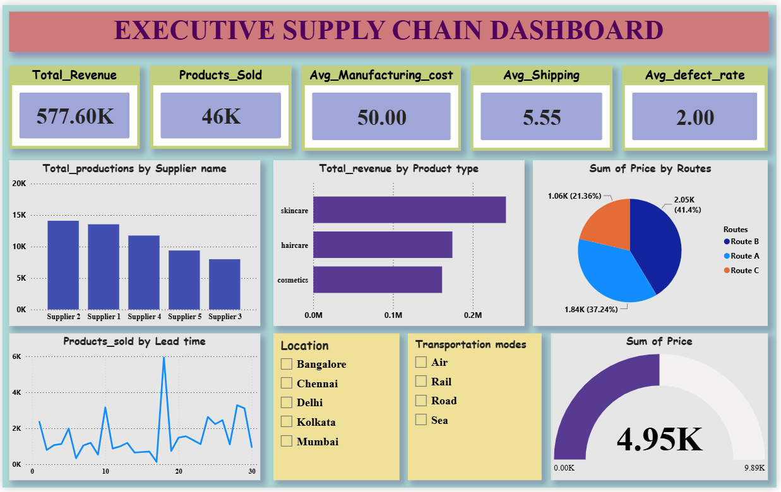

- Total Revenue: ₹577.6K
- Products Sold: 46K
- Average Manufacturing Cost: ₹50.00
- Average Shipping Cost: ₹5.55
- Average Defect Rate: 2.00%

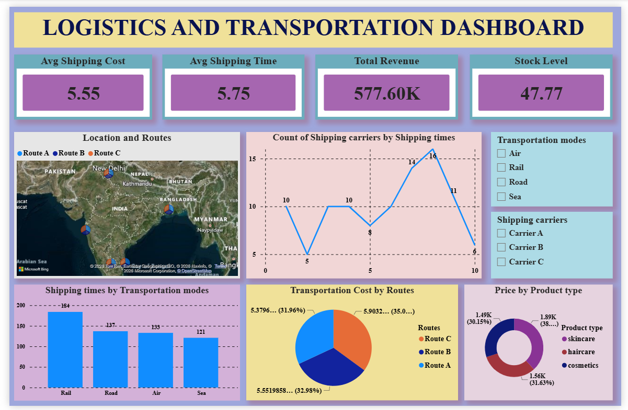

- Average Shipping Cost: 5.55
- Average Shipping Time: 5.75
- Total Revenue: 577.60K
- Stock Level: 47.77

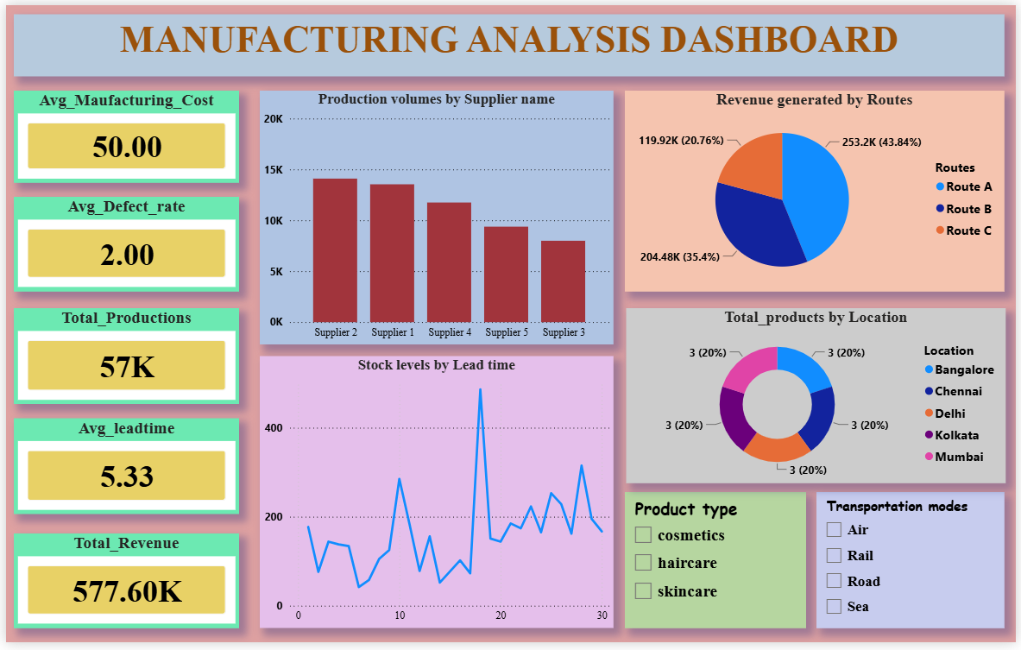

- Average Manufacturing Cost: 50.00
- Average Defect Rate: 2.00
- Total Productions: 57K
- Average Lead Time: 5.33
- Total Revenue: 577.60K

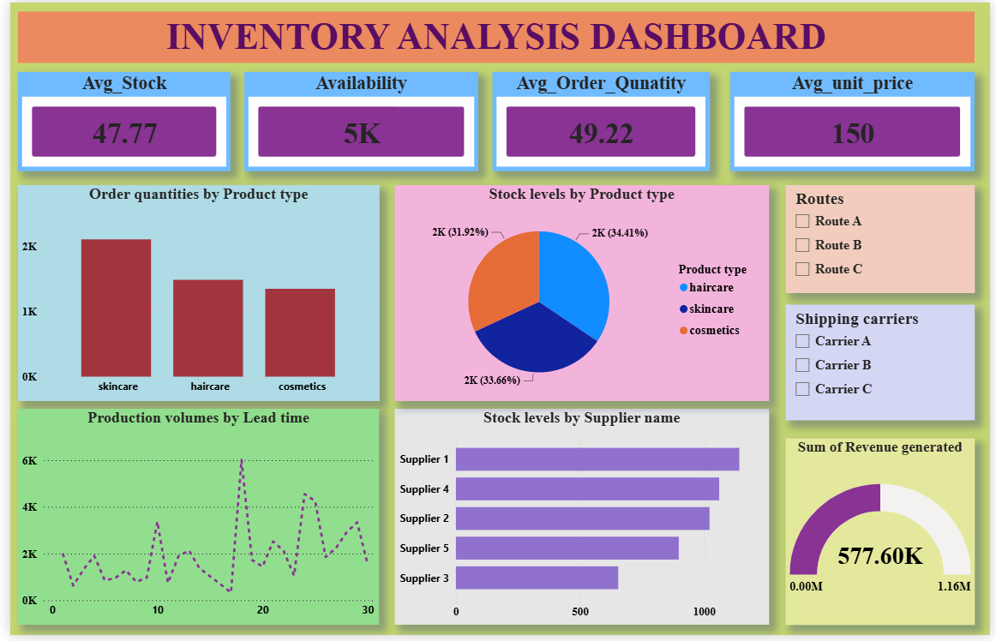

- Average Stock: 47.77
- Availability: 5K
- Average Order Quantity: 49.22
- Average Unit Price: 150
- Sum of Revenue Generated: 577.60K

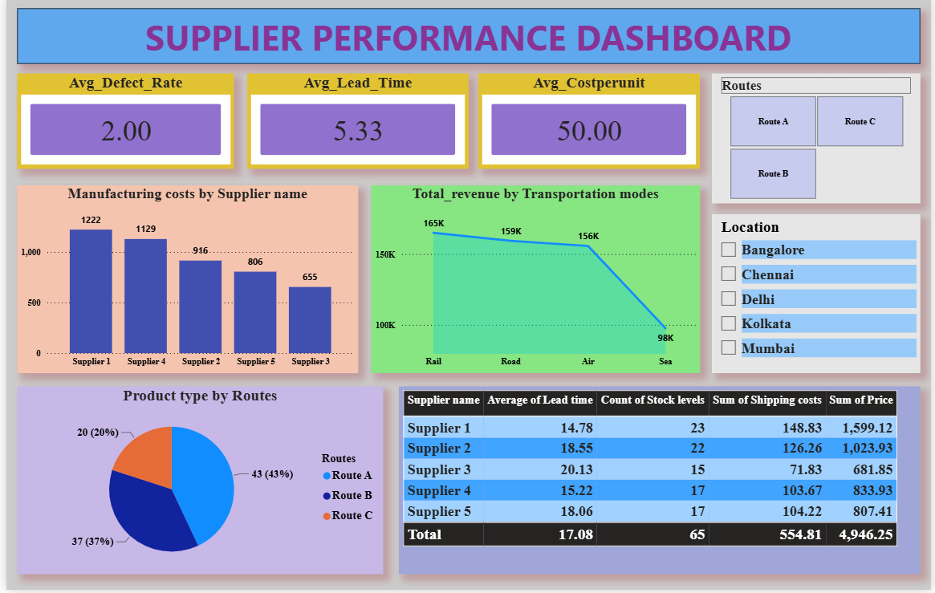

- Average Defect Rate: 2.00
- Average Lead Time: 5.33
- Average Cost per Unit: 50.00
- Total Revenue: 4,946.25
- Total Shipping Cost: 554.81.

Insights

- Revenue: Consistent across dashboards (~₹577K), showing stable profitability.
- Products & Inventory: 46K units sold; stock levels healthy (~48 units average, 5K available).
- Costs: Manufacturing cost steady at ₹50 per unit; shipping cost ~₹5.5 per unit.
- Quality: Defect rate low at 2%, indicating good product consistency.
- Logistics: Average shipping time ~5.7 days; Route A and Rail transport most efficient.
- Manufacturing: 57K total productions; lead time ~5.3 days, suppliers 1 & 2 lead output.
- Suppliers: Supplier 1 highest revenue, Supplier 3 slower lead time — improvement needed.
- Inventory & Orders: Avg. order quantity ~49 units; skincare products dominate revenue and stock.

Recommendations and Suggestions
- Optimize Logistics: Focus on reducing average shipping time (~5.7 days) by improving route planning and prioritizing efficient modes like Rail and Route A.
- Supplier Management: Strengthen collaboration with Supplier 3 to reduce lead time; maintain Supplier 1 and 2’s strong production performance.
- Cost Control: Keep manufacturing cost stable at ₹50 per unit; explore bulk shipping or route optimization to lower average shipping cost (~₹5.5).
- Quality Assurance: Maintain defect rate at 2% or lower through stricter quality checks and supplier audits.
- Inventory Efficiency: Balance stock levels with demand; avoid overstocking while ensuring availability (~5K units).
- Product Strategy: Skincare products drive the highest revenue — expand this category while monitoring performance of other product types.
- Data Integration: Continue using Power BI dashboards for real-time monitoring; integrate predictive analytics (Python/SQL) for demand forecasting.
- Executive Reporting: Present KPIs in a simplified format for decision-makers, highlighting revenue, cost, quality, and logistics metrics.

Conclusion
The supply chain analysis project highlights that the organization has built a resilient and efficient system, capable of sustaining profitability while maintaining cost control and product quality. Revenue performance remains consistent across dashboards, supported by stable manufacturing costs and low defect rates, which reflect strong production management and effective quality assurance. Inventory levels are balanced to meet demand without excessive overstocking, while logistics analysis shows that certain routes and transport modes, particularly Rail and Route A, are highly efficient and contribute significantly to revenue. These findings confirm that the supply chain is well-structured and data-driven, with clear strengths in cost efficiency, quality, and inventory management.
At the same time, the analysis identifies areas for improvement that can further enhance responsiveness and competitiveness. Average shipping times and supplier lead times remain slightly higher than desired, suggesting the need for better route optimization, closer supplier collaboration, and investment in faster delivery mechanisms. Supplier performance shows reliable contributions from key partners, but also highlights opportunities to reduce delays and improve consistency. Overall, the project demonstrates that the supply chain is not only stable and profitable but also positioned for continuous improvement, with actionable insights that support strategic decision-making and long-term growth

